I summarize the methods and materials I used to make the latest Ib module, ‘Ib Filter Module’.

I’ll demonstrate for one module. The only difference between the three types (15, 25, and 200 gain) are in the values of resistance and capacitors as shown in the table of Figure 1.

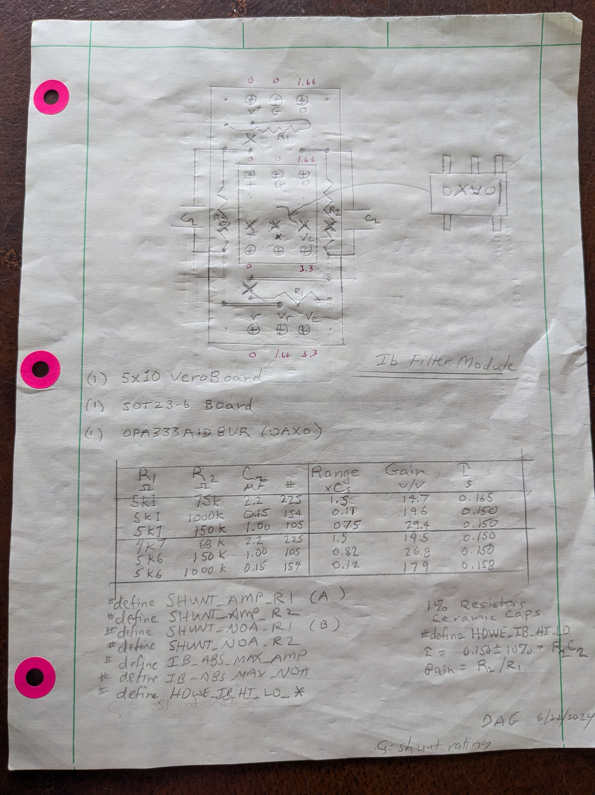Figure 1: Ib Filter Module Schematic
Next I solder SOT23-6 adapter boards to headers and tin the mount pads as shown in Figure 2 and Figure 3.

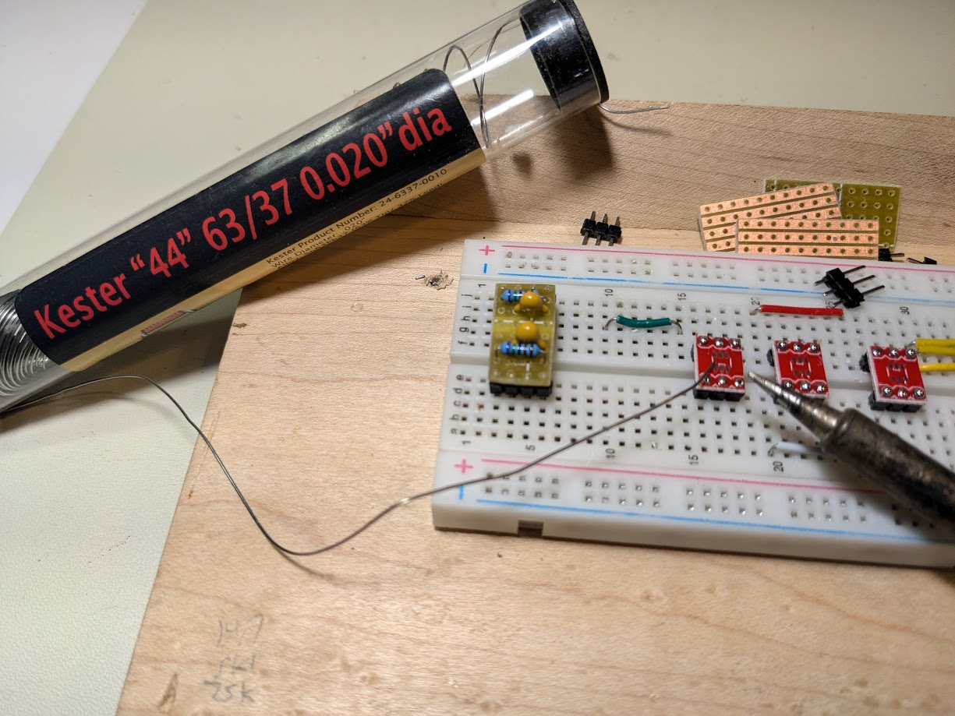Figure 2: Install Headers to SOT op-amp Adapter Boards and Pre-tin
Figure 3: Ready Op-Amp Mount Boards
Now we’re ready to soulder the op-amps to the boards. It is helpful to use sticky putty to hold them in place for the first tack. This is shown in Figure 4.
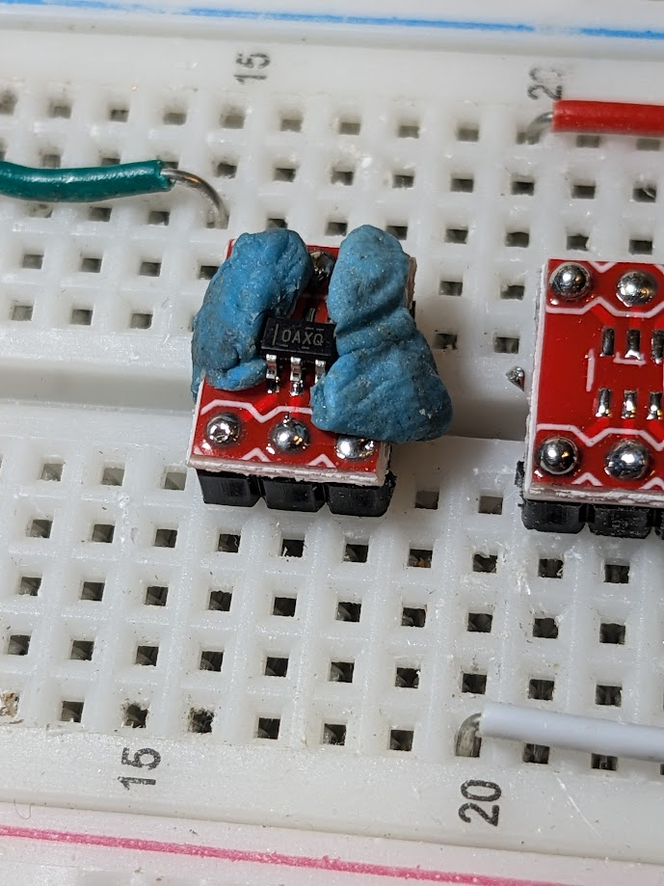Figure 4: Tack Op-Amp to Board

I like to use the sharpest possible iron tip. First I try to get the pre-tin to take hold. When that doesn’t work I tap the iron with the thinnest possible solder to help out. Check connections with ohmmeter!

Finish soldering all the pins and paint a stripe on the indexed side of the chip (vertical stripe), Figure 5. This is unnecessary given that there are only 5 pins out of 6 used but it makes things a little easier to see.
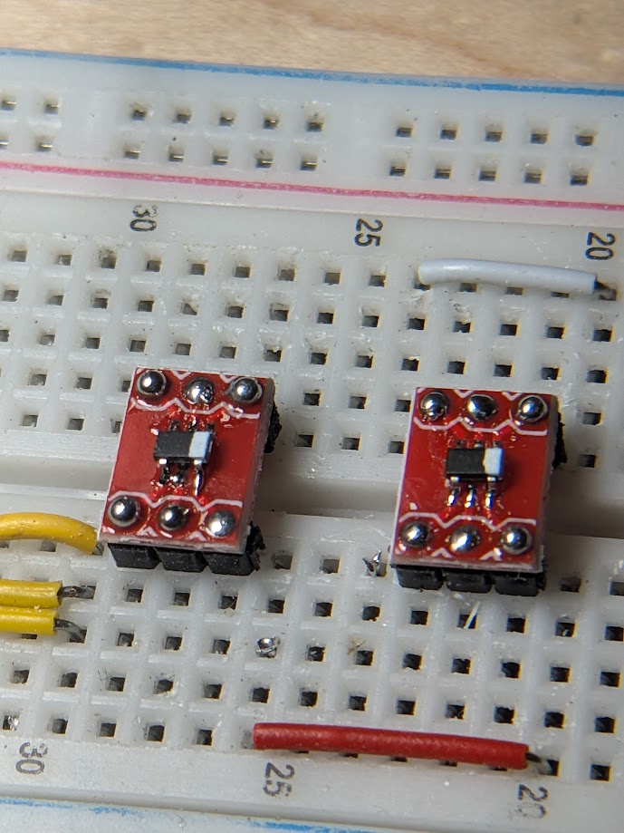Figure 5: Completed Op-Amp Board
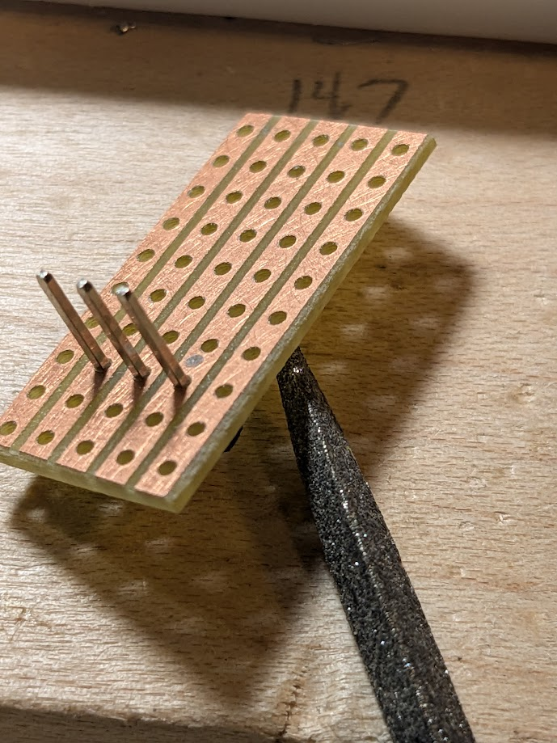Figure 6: Use Board to Push Header Apron Away from Solder Joint Area
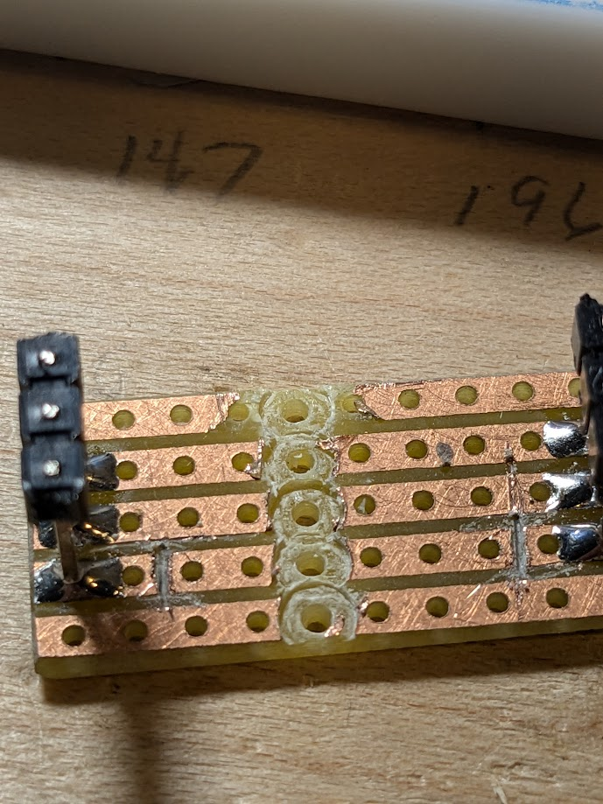Figure 7: Then Tack One Leg, Adjust Perpendicular by Reheating, Then Solder All
Figure 8: Insert All the Components. Twist Leads to Hold in Place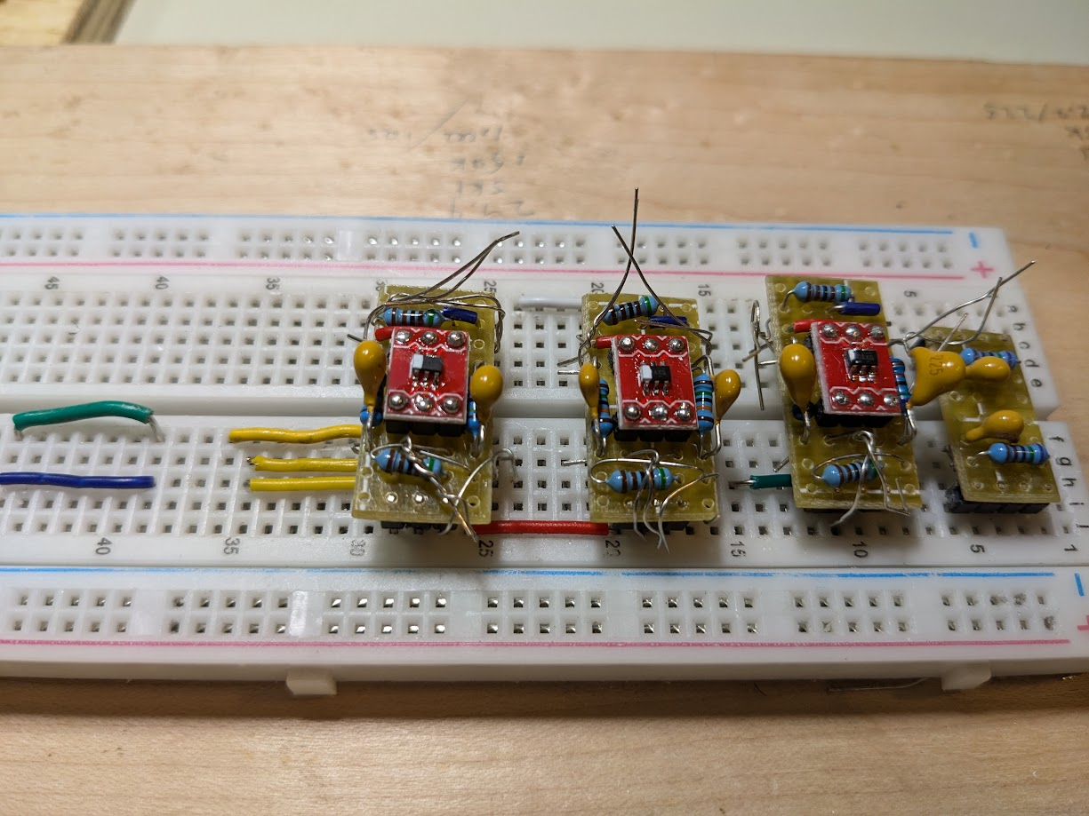
When all the soldering is done I install into one of my devices with V+ and V- tied together then grounded through a 100-500 ohm pull-down resistor. The output will be 1.65 = v3v/2. Inputs + and – to the op-amp will be 0.
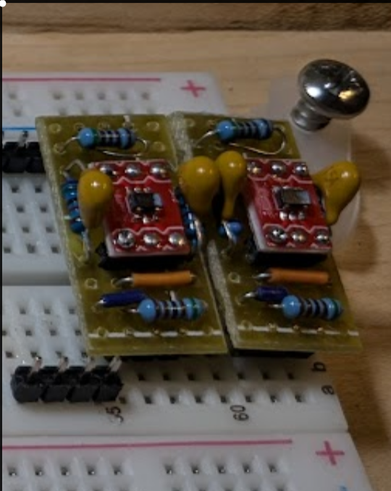Figure 9: Solder. Trim with Flush Cutters. Check Continuity

I’m still working out how to mark these with their gain. Easy to read the capacitor #.

